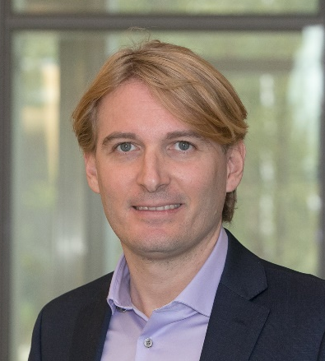
Andrea Alù is a Distinguished Professor at the City University of New York (CUNY), the Founding Director of the Photonics Initiative at the CUNY Advanced Science Research Center, the Einstein Professor of Physics at the CUNY Graduate Center, Professor of Electrical Engineering at the City College of New York, Senior Research Scientist and Adjunct Professor at the University of Texas at Austin. He received the Laurea, MS and PhD degrees from the University of Roma Tre, Rome, Italy, respectively in 2001, 2003 and 2007. After performing postdoctoral research at the University of Pennsylvania, in 2009 he joined the faculty of the University of Texas at Austin, where he was the Temple Foundation Endowed Professor until 2018. In 2015 he was the Royal Netherlands Academy of Arts and Sciences (KNAW) Visiting Professor at the AMOLF Institute in the Netherlands.
His research interests cover metamaterials and metasurfaces, applied electromagnetics, optics, nanophotonics, and acoustics. He is currently the Editor-in-Chief of Optical Materials Express and has been serving on the Editorial Board of Reviews of Electromagnetics, Physical Review B, Advanced Optical Materials, Laser and Photonics Reviews, New Journal of Physics, EPJ Applied Metamaterials and ISTE Metamaterials. He served as Associate Editor for IEEE Antennas and Wireless Propagation Letters, Optics Express, Applied Physics Letters, MDPI Materials, Scientific Reports, Metamaterials, and Advanced Electromagnetics. He has guest edited special issues for the IEEE Journal of Selected Topics in Quantum Electronics, Proceedings of IEEE (twice), IEEE Transactions on Antennas and Propagation, IEEE Antennas and Wireless Propagation Letters (twice), Nanophotonics, Journal of Optics, Journal of the Optical Society of America A and B, Photonics and Nanostructures - Fundamentals and Applications, Optics Communications, Metamaterials, and Sensors on a variety of topics involving metamaterials, plasmonics, optics and electromagnetic theory.
Dr. Alù is currently the President of the Metamorphose Virtual Institute for Artificial Electromagnetic Materials and Metamaterials, and the Director of the Simons Collaboration on Extreme Wave Phenomena, an OSA Traveling Lecturer since 2010, and an IEEE AP-S Distinguished Lecturer since 2014. He is the chair of the IEEE joint AP-S, MTT-S, Photonics, NTC chapter in New York, and was a member of the Administrative Committee of the IEEE Antennas and Propagation Society, and the IEEE joint AP-S and MTT-S chapter chair for Central Texas. He is a Simons Investigator in Physics since 2016 and a full member of URSI, a Fellow of IEEE, NAI, AAAS, MRS, OSA, SPIE and APS, and a Highly Cited Researcher (Clarivate Web of Science) since 2017. Over the last few years, he has received several awards for his research activities, including the SPIE Mozi Award (2024), the IEEE Antennas and Propagation Society Distinguished Achievement Award (2023), the Brillouin Medal (2021), the Blavatnik National Award in Physical Sciences and Engineering (2021), the AAAFM Heeger Award (2021), the Dan Maydan Prize in Nanoscience (2021), the IEEE Kiyo Tomiyasu Award (2020), the DoD Vannevar Bush Faculty Fellowship (2019), IUMRS Young Researcher Award (2018), ICO Prize in Optics (2016), the inaugural MDPI Materials Young Investigator Award (2016), the Kavli Foundation Early Career Lectureship in Materials Science (2016), the inaugural ACS Photonics Young Investigator Award Lectureship (2016), the Edith and Peter O’Donnell Award in Engineering (2016), the NSF Alan T. Waterman Award (2015), the IEEE MTT Outstanding Young Engineer Award (2014), the OSA Adolph Lomb Medal (2013), the IUPAP Young Scientist Prize in Optics (2013), the Franco Strazzabosco Award for Young Engineers (2013), the SPIE Early Career Investigator Award (2012), the URSI Issac Koga Gold Medal (2011), an NSF CAREER award (2010), the AFOSR and the DTRA Young Investigator Awards (2010, 2011), Young Scientist Awards from URSI General Assembly (2005) and URSI Commission B (2010, 2007 and 2004). His students have also received several awards, including several student paper awards at IEEE Antennas and Propagation and URSI Symposia.

